Test Case: Login & Profile Edge Case Testing

Project | Team 38 – AI Digital Marketing (Team B)
Status | Complete
Tester | Minh Vu

Preconditions
- The feature has been deployed to a live/staging URL that is reachable without a local dev environment.
- A valid, registered test account (email + password) exists and is known to the tester.

Test Data
- Deployed URL: http://localhost:3001/
- Valid test account email / password: Cuong20040607@gmail.com
- Invalid password to test: WRONGpassword
- Unregistered email to test: fake_email.com
- Team page direct URL: http://localhost:3001/team
- Test profile with missing photo: N/A
- Test profile with long blurb: N/A

Test Steps
Step | Action | Expected Result
1 | On the deployed URL, go to the Login page and attempt to log in with an incorrect password for a valid/registered email. | Login is rejected; a clear error message is shown (e.g. "Invalid email or password"); user is not granted access and stays on the Login page.
2 | Attempt to log in with an email address that is not registered in the system. | Login is rejected with a clear error message; no account information is leaked (e.g. does not reveal whether the email exists); user stays on the Login page.
3 | Attempt to log in with an empty email field, an empty password field, and both fields empty (submit the form each time). | Appropriate validation errors are shown for each case; the form does not submit and no login occurs.
4 | While logged out (no active session / cleared cookies), paste the Team page URL directly into the browser address bar and navigate to it. | User is redirected to the Login page (or shown an "unauthorized" state) — the Team page content is NOT accessible without logging in.
5 | Log in with valid credentials, then open/view a team member profile that has no photo uploaded. | The page shows a graceful fallback (e.g. placeholder avatar/initials) — no broken image icon, no layout shift, no console error.
6 | Open/view (or create) a team member profile with an unusually long blurb/bio (e.g. several paragraphs of text). | The long text wraps, truncates, or scrolls gracefully within its container — no overflow outside the card, no broken layout, no text cut off without indication.

1.On the deployed URL, go to the Login page and attempt to log in with an incorrect password for a valid/registered email.

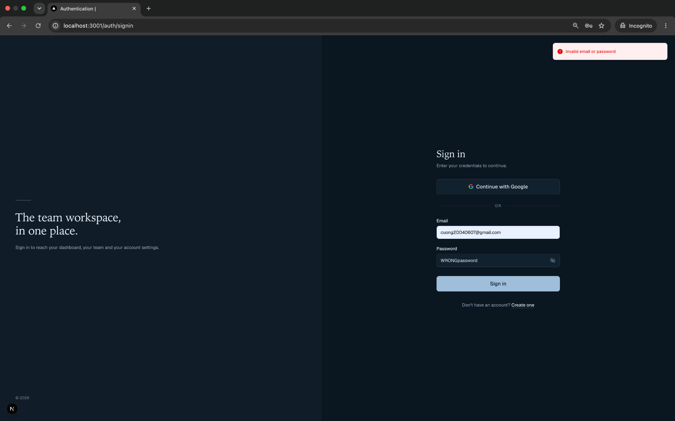

2. Attempt to log in with an email address that is not registered in the system.

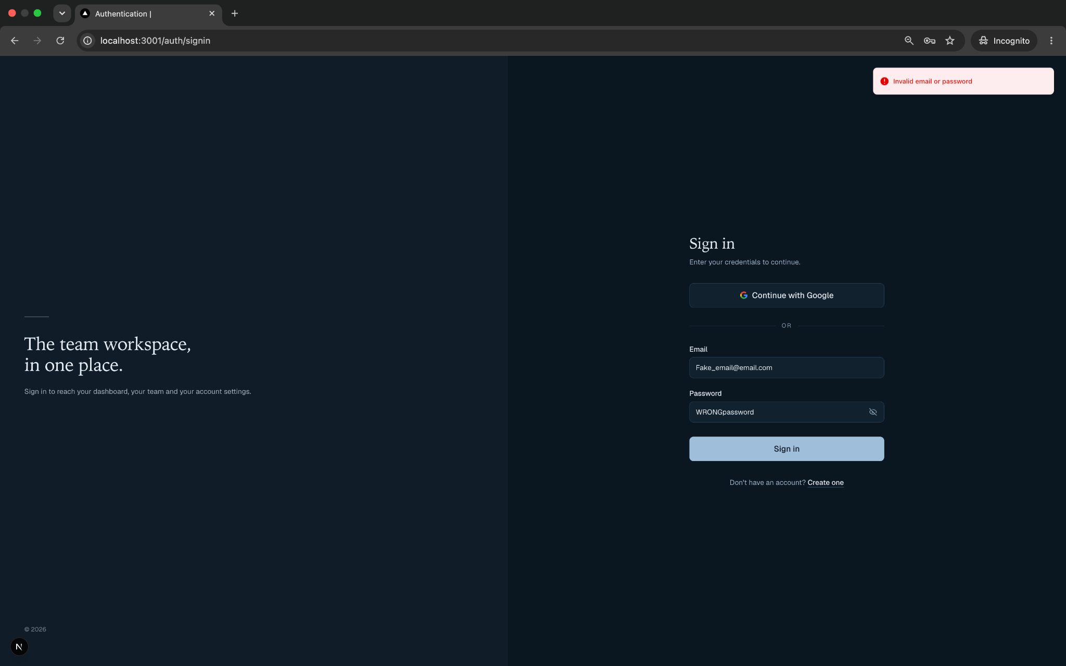

3. Attempt to log in with an empty email field, an empty password field, and both fields empty (submit the form each time).
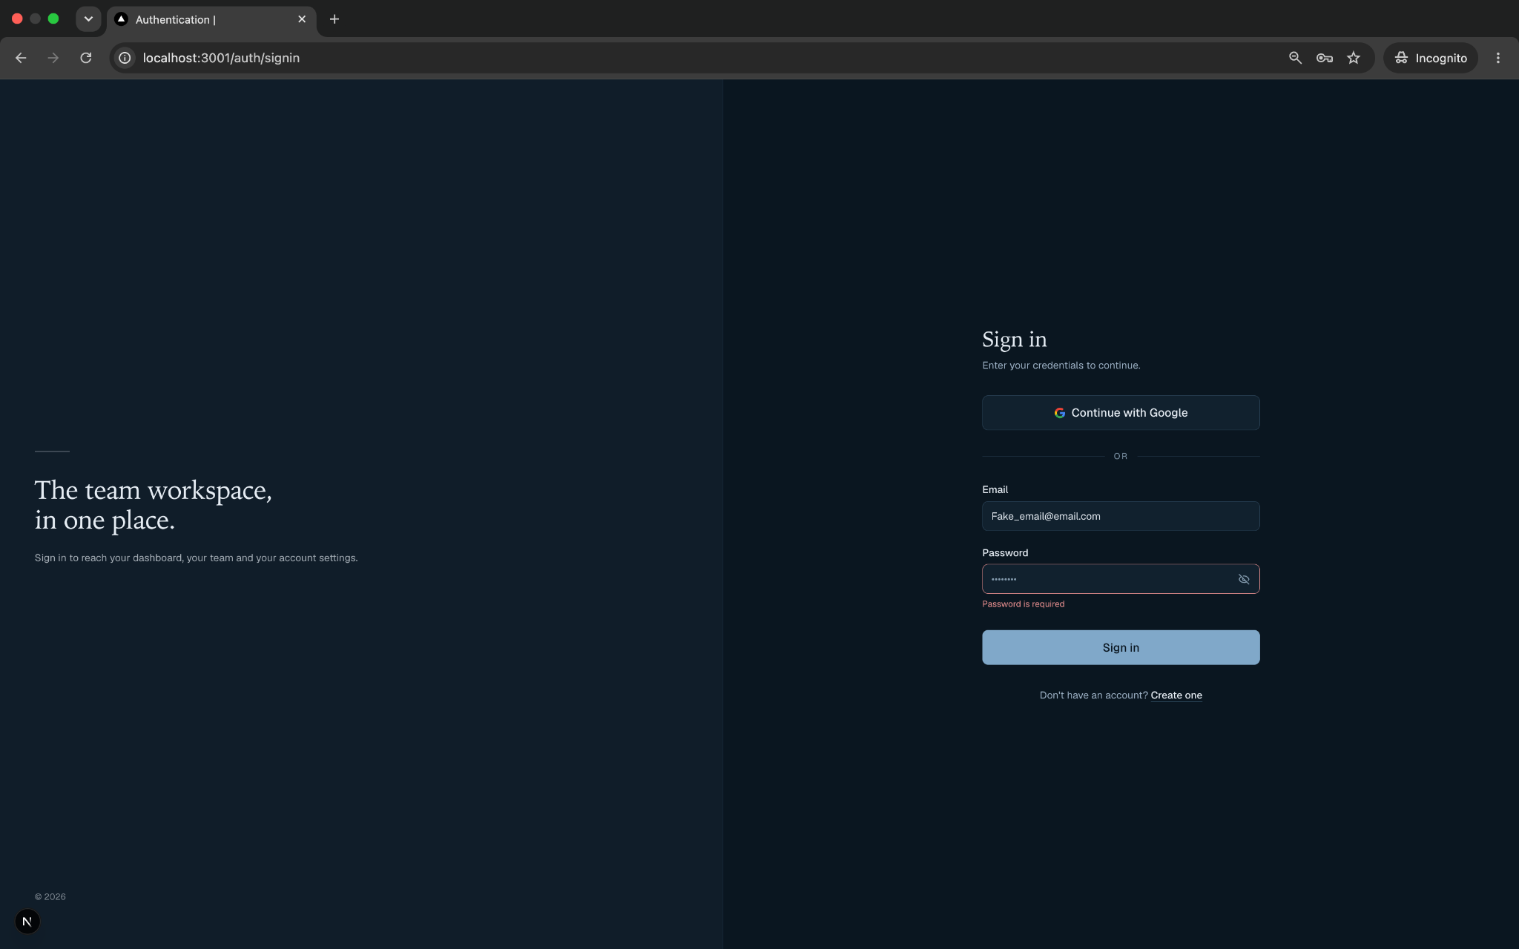
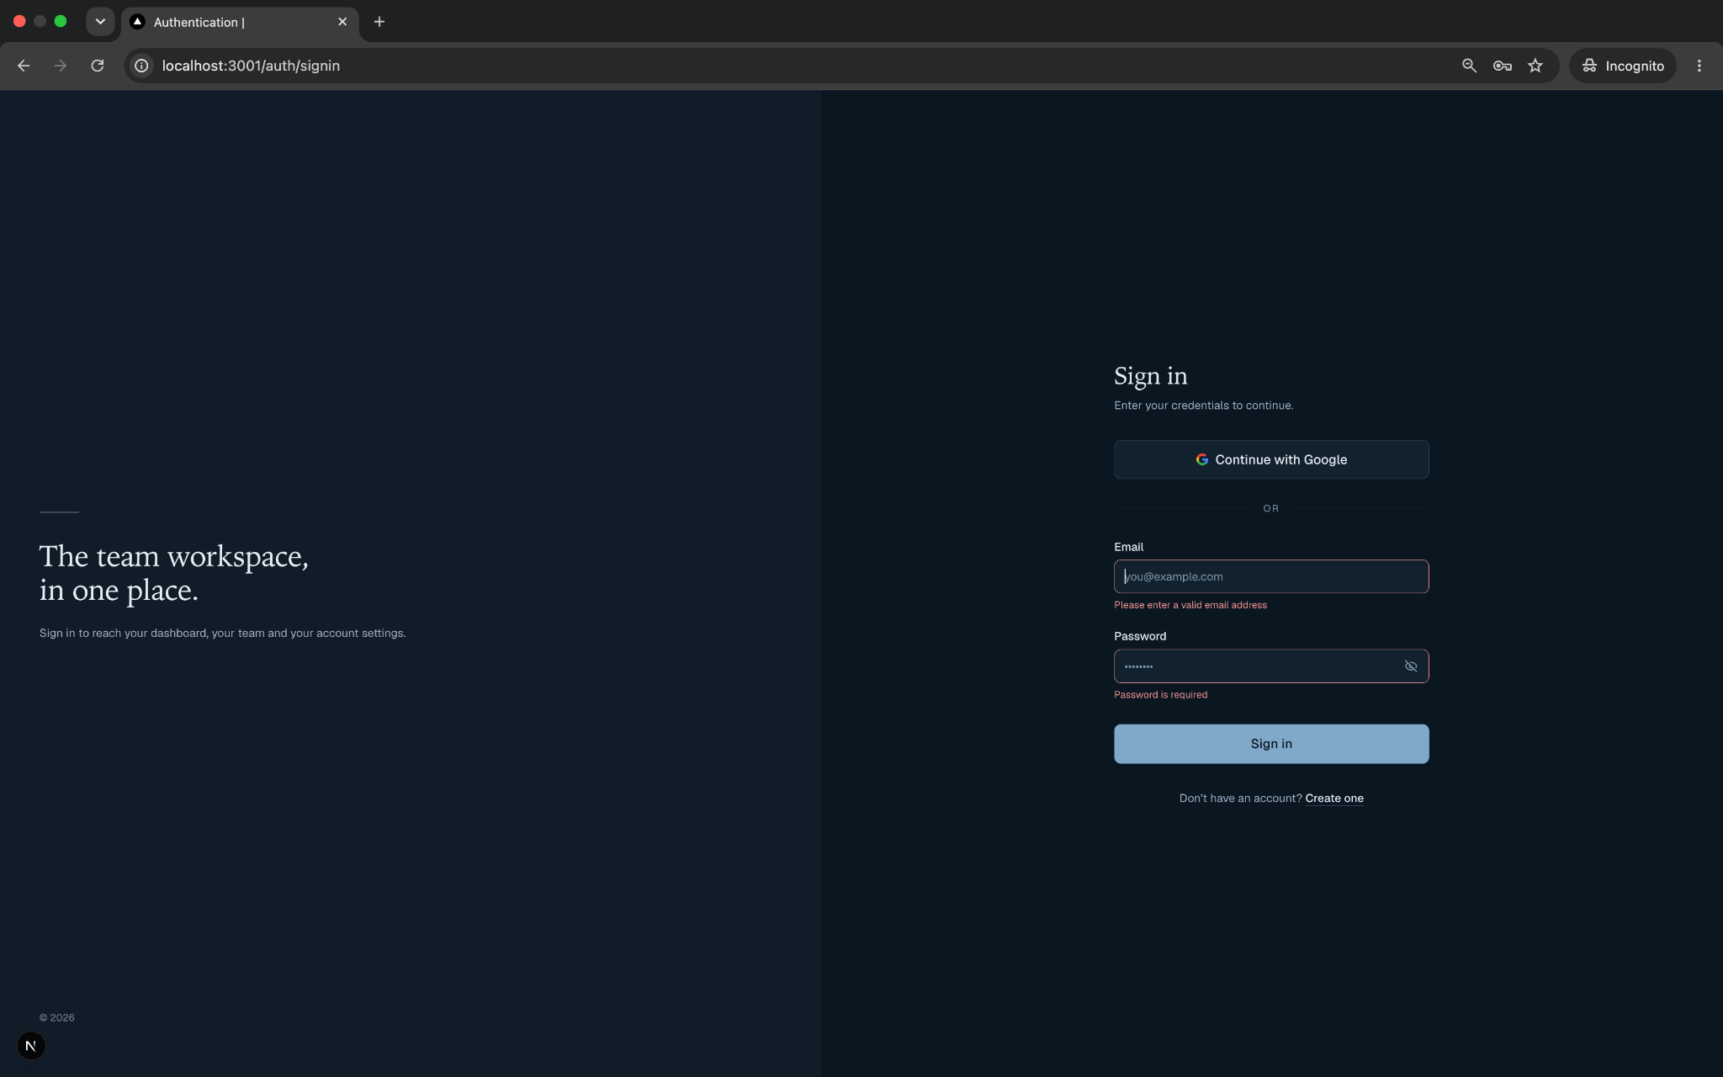
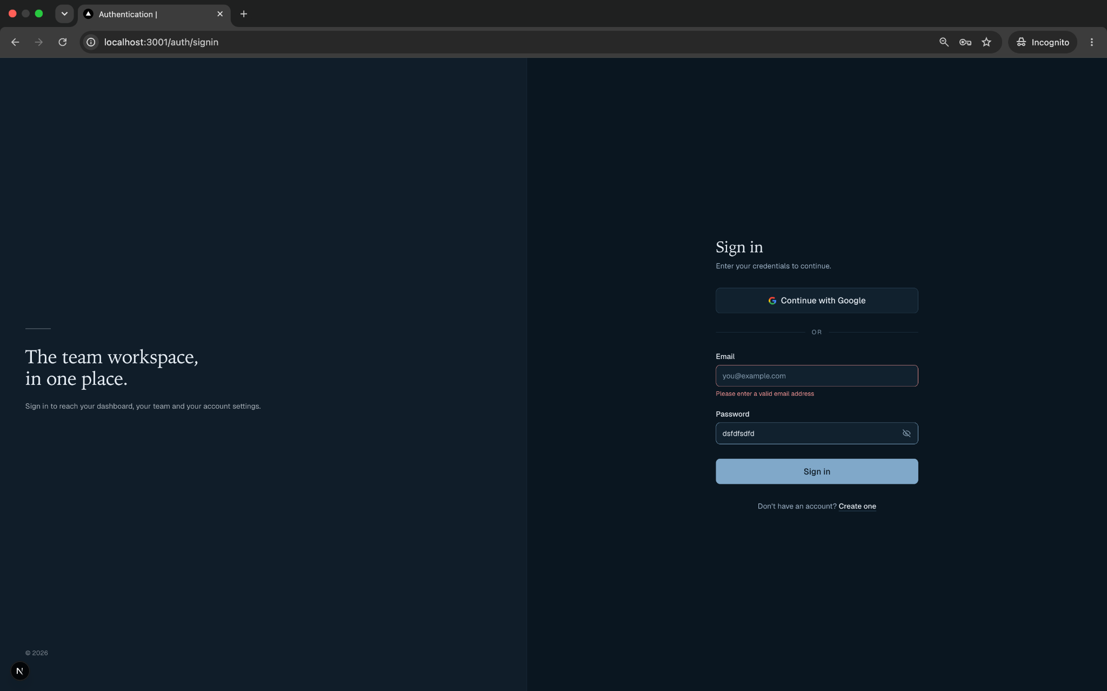
4.While logged out (no active session / cleared cookies), paste the Team page URL directly into the browser address bar and navigate to it.

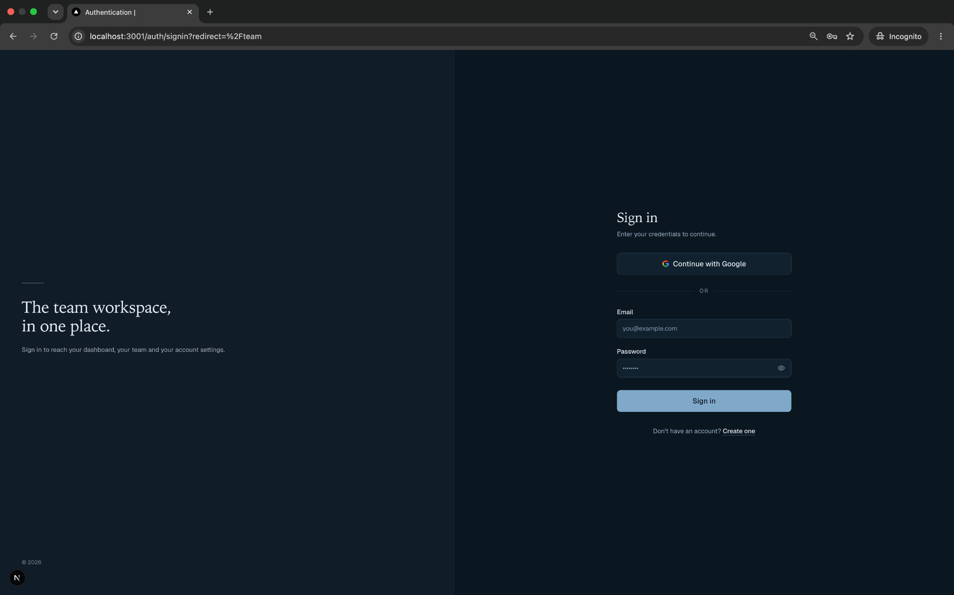
5. Log in with valid credentials, then open/view a team member profile that has no photo uploaded.Log in with valid credentials, then open/view a team member profile that has no photo uploaded.
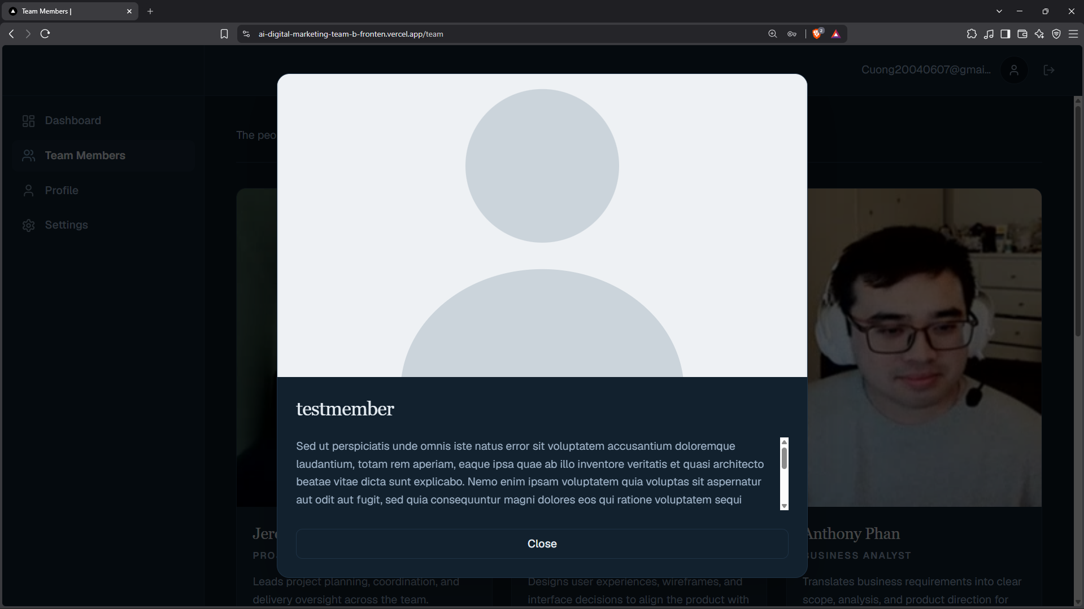

6. Open/view (or create) a team member profile with an unusually long blurb/bio (e.g. several paragraphs of text).



